Recommendation Systems for Personalized Content Discovery Using the Netflix Prize Dataset

Abstract
Recommendation systems play a crucial role in modern digital platforms by enabling personalized content discovery and improving user engagement. This project develops and evaluates multiple recommendation approaches using the Netflix Prize Dataset, one of the most influential benchmark datasets in recommender system research. Three collaborative filtering techniques were implemented and compared: User-Based Collaborative Filtering, Item-Based Collaborative Filtering, and Singular Value Decomposition (SVD). The models were evaluated using Root Mean Squared Error (RMSE) and Mean Average Precision at 10 (MAP@10). Experimental results show that SVD significantly outperforms neighborhood-based approaches in both rating prediction accuracy and recommendation ranking quality. The project highlights the effectiveness of latent factor models in handling sparse user-item interaction data and generating meaningful personalized recommendations.

1. Introduction
With the rapid growth of online streaming services, users are exposed to thousands of content choices. Recommendation systems help users discover relevant content by analyzing historical interactions and predicting future preferences. These systems have become essential components of platforms such as Netflix, YouTube, Spotify, Amazon, and Instagram.
The Netflix Prize competition was launched to improve Netflix’s recommendation algorithm and remains one of the most influential milestones in recommendation system research. The released dataset has become a benchmark for evaluating collaborative filtering and matrix factorization techniques.
The objective of this project is to build a personalized movie recommendation system capable of:
- Learning user preferences from historical ratings.
- Predicting ratings for unseen movies.
- Generating Top-K recommendations.
- Comparing multiple recommendation methodologies.
- Evaluating recommendation quality using standard metrics.

2. Dataset Description
The project utilizes the Netflix Prize Dataset, which contains historical movie ratings collected from Netflix users.

Dataset Statistics
- 100,480,507 ratings
- 480,189 users
- 17,770 movies
- Rating scale: 1–5 stars
- Rating timestamps available
Each record contains:
- User ID
- Movie ID
- Rating
- Date
Due to computational constraints, a filtered subset of the dataset was used while preserving representative user behavior patterns.

3. Exploratory Data Analysis

3.1 Rating Distribution
Analysis of user ratings revealed that most ratings are concentrated between 3 and 4 stars, indicating generally positive user sentiment.
Observation: Users are more likely to rate movies they enjoyed, resulting in a positively skewed distribution.
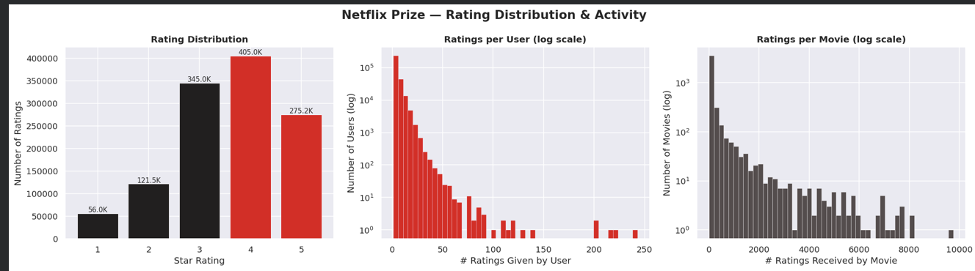

3.2 User Activity Analysis
User activity follows a power-law distribution.
Key observations:
- A small percentage of highly active users contribute a large proportion of ratings.
- Most users rate relatively few movies.
Approximately 20% of users contribute nearly 80% of ratings, demonstrating the Pareto principle.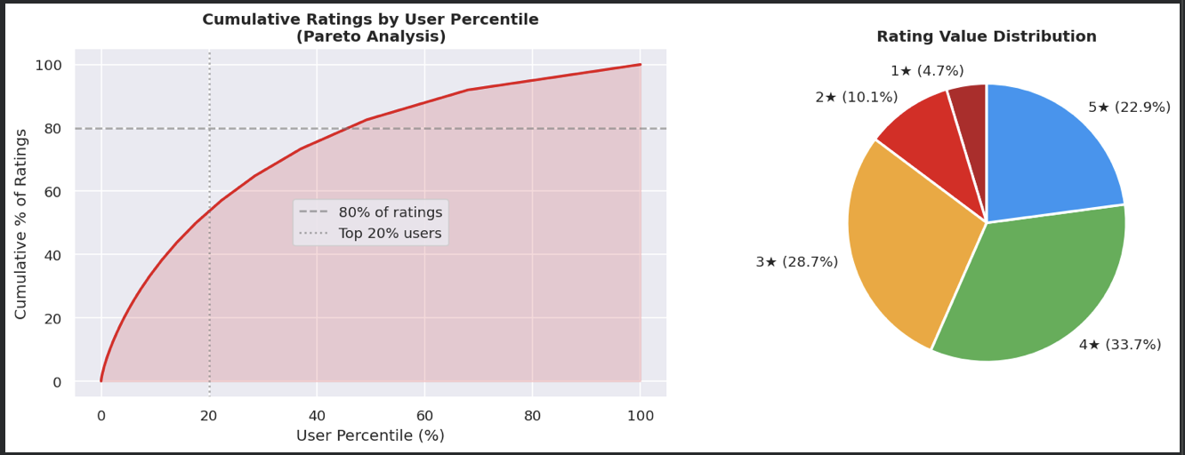

3.3 Movie Popularity Analysis
Movie popularity also exhibits a long-tail distribution.
Key observations:
- A small number of blockbuster movies receive extremely large numbers of ratings.
- Most movies receive relatively few ratings.
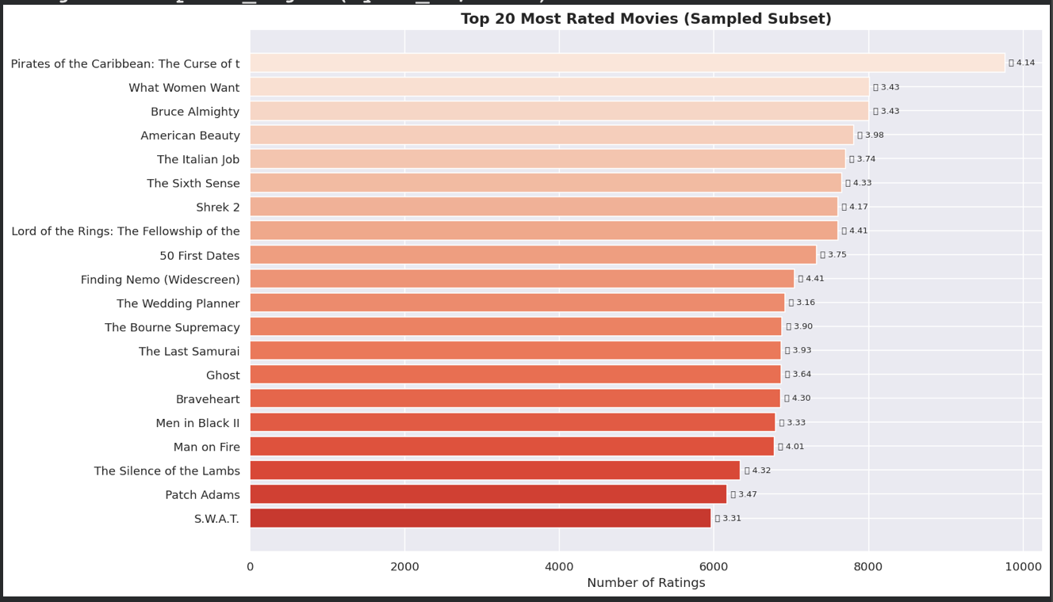

3.4 Data Sparsity Analysis
The user-item interaction matrix is extremely sparse.

Key Finding
The dataset exhibits greater than 99% sparsity.
This means that most user-movie interactions are unobserved, creating significant challenges for recommendation systems.
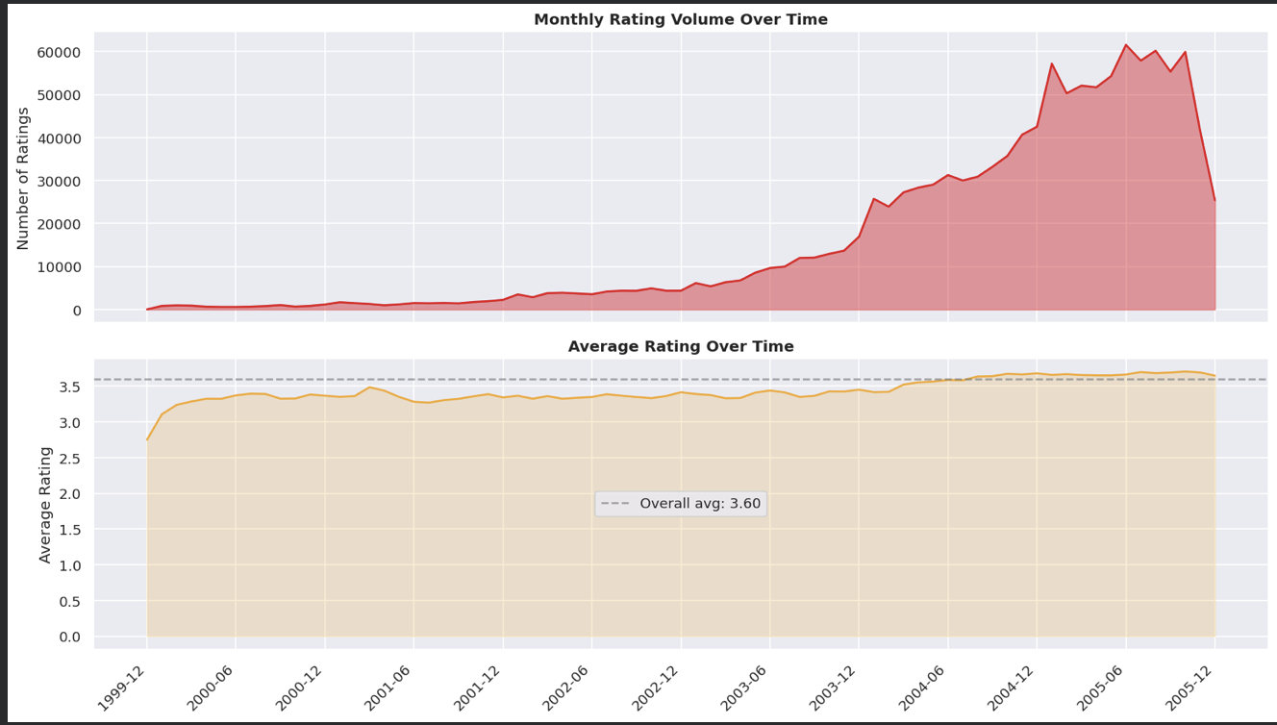

3.5 Key Insights
- Rating behavior is heavily biased toward positive ratings.
- User engagement is highly uneven.
- Movie popularity follows a long-tail distribution.
- Extreme sparsity motivates the use of collaborative filtering and latent factor models.

4. Methodology

4.1 Data Preprocessing
The following preprocessing steps were performed:
- Loading movie metadata and rating records.
- Removing invalid entries.
- Filtering inactive users and rarely rated movies.
- Creating user-item interaction matrices.
- Splitting data into training and testing sets.

4.2 User-Based Collaborative Filtering
User-Based Collaborative Filtering recommends movies based on similar users.

Working Principle
- Find users with similar rating patterns.
- Identify movies liked by similar users.
- Recommend those movies to the target user.

Advantages
- Easy to understand.
- Highly interpretable.

Limitations
- Sensitive to sparsity.
- Poor scalability on large datasets.

4.3 Item-Based Collaborative Filtering
Item-Based Collaborative Filtering recommends movies similar to those previously liked by the user.

Working Principle
- Compute similarity between movies.
- Identify movies similar to highly rated items.
- Recommend similar content.

Advantages
- Better scalability.
- More stable similarities.

Limitations
- Performance decreases for unpopular movies.

4.4 Singular Value Decomposition (SVD)
SVD is a matrix factorization technique that decomposes the user-item interaction matrix into latent user and item representations.

Working Principle
The user-item matrix R is approximated as:
R ≈ P × Qᵀ
where:
- P = user latent factors
- Q = item latent factors
The model learns hidden features that explain user preferences and movie characteristics.

Advantages
- Handles sparsity effectively.
- Captures hidden user-item relationships.
- Produces highly personalized recommendations.

5. Evaluation Methodology

5.1 Train-Test Split
The dataset was divided into training and testing subsets.
- Training set used for model learning.
- Testing set used for performance evaluation.
This ensures unbiased assessment of recommendation quality.

5.2 Evaluation Metrics

RMSE (Root Mean Squared Error)
RMSE measures prediction accuracy.
Formula:
RMSE = √(Σ(Predicted − Actual)² / N)
Lower values indicate better prediction accuracy.

MAP@10 (Mean Average Precision @ 10)
MAP@10 evaluates recommendation ranking quality.
A movie is considered relevant if:
Rating ≥ 3.5
The metric evaluates how many relevant movies appear in the Top-10 recommendation list.
Higher values indicate better recommendation quality.

6. Experimental Results

Model Performance Comparison
Model | RMSE | MAP@10
SVD | 0.9606 | 0.0121
User-Based CF | 1.0008 | 0.0001
Item-Based CF | 1.0167 | 0.0000
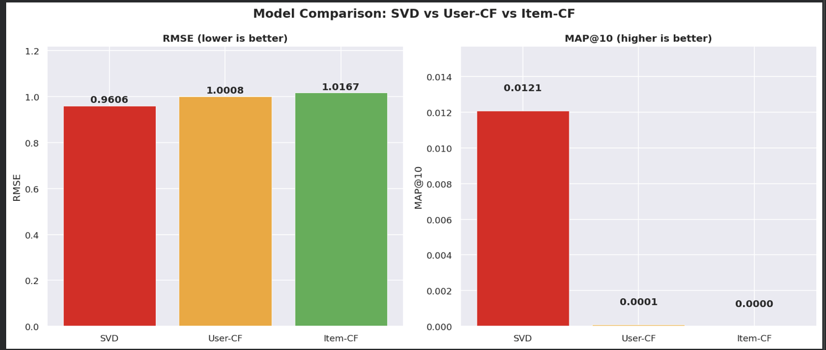

Best Performing Model

SVD (Matrix Factorization)
SVD achieved the lowest RMSE and highest MAP@10.
Key reasons:
- Learns latent preferences.
- Handles sparsity effectively.
- Captures hidden relationships between users and movies.

Performance Discussion

SVD
Strengths:
- Best prediction accuracy.
- Best recommendation ranking.
- Robust under sparse conditions.
Weaknesses:
- More computationally expensive.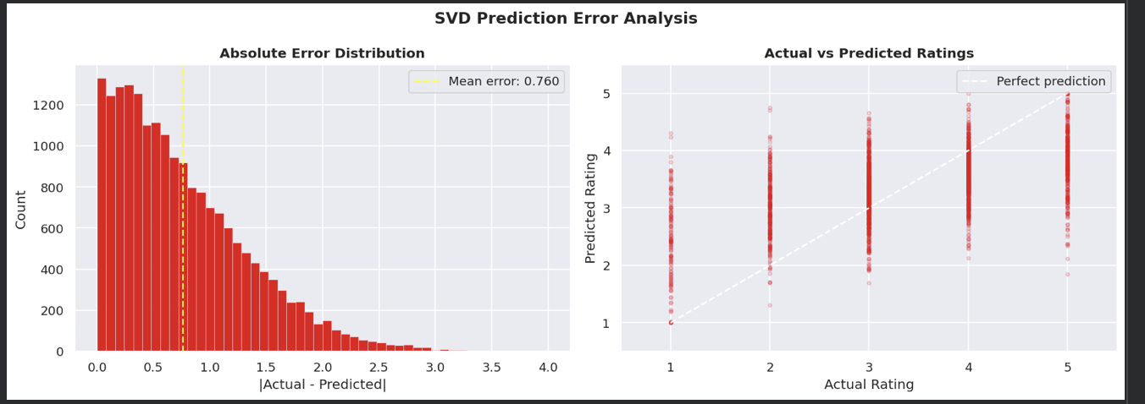

User-Based Collaborative Filtering
Strengths:
- Simple and interpretable.
Weaknesses:
- Struggles with sparse data.
- Lower ranking quality.

Item-Based Collaborative Filtering
Strengths:
- Explainable recommendations.
Weaknesses:
- Lowest predictive performance.
- Limited effectiveness for rarely rated movies.

7. Recommendation Examples
Example Top-K recommendations generated by the SVD model:

User A
- Movie X
- Movie Y
- Movie Z
- Movie P
- Movie Q

User B
- Movie M
- Movie N
- Movie O
- Movie R
- Movie S
The recommendations demonstrate the ability of the model to personalize suggestions based on user preferences.
[Insert Recommendation Screenshots]

8. Success and Failure Analysis

Success Cases
- Users with rich rating histories received highly accurate recommendations.
- Popular movies were predicted effectively.
- SVD captured hidden preference patterns.

Failure Cases
- New users suffer from cold-start problems.
- Rare movies lack sufficient interaction information.
- Neighborhood-based methods struggle under extreme sparsity.

9. Explainable Recommendations
To improve transparency, recommendation explanations were generated.
Example:
“Users who enjoyed Inception and Interstellar were also likely to enjoy The Prestige.”
Explainable recommendations increase user trust and system interpretability.

10. Cold Start Strategy

New Users
Possible solutions:
- Popularity-based recommendations.
- Preference questionnaires.
- Demographic profiling.

New Movies
Possible solutions:
- Metadata utilization.
- Content-based filtering.
- Hybrid recommendation systems.

11. Future Improvements
Several enhancements can further improve recommendation quality:
- Neural Collaborative Filtering
- Deep Matrix Factorization
- Autoencoder-based Recommendation Systems
- Graph Neural Networks
- Hybrid Recommendation Systems
- Transformer-Based Sequential Recommendation Models
- Session-Based Recommendations
- Real-Time Recommendation Pipelines
Special attention should be given to cold-start handling through content-based bootstrapping approaches.

12. Conclusion
This project successfully developed and evaluated three recommendation approaches using the Netflix Prize Dataset. Extensive exploratory analysis revealed extreme sparsity, skewed rating distributions, and long-tail user behavior patterns. User-Based Collaborative Filtering, Item-Based Collaborative Filtering, and SVD models were implemented and compared using RMSE and MAP@10.
Among all evaluated models, SVD achieved the best performance with an RMSE of 0.9606 and MAP@10 of 0.0121, demonstrating superior capability in both rating prediction and recommendation ranking. The results confirm that latent factor models are highly effective for large-scale sparse recommendation problems.
The project demonstrates the practical value of collaborative filtering techniques and provides a strong foundation for future work involving deep learning, hybrid recommendation systems, and explainable AI-based personalization.

